DRIVER DROWSINESS DETECTION

Abstract— This research paper is a review of my project “Driver Drowsiness Detection”. The idea behind this project is the accidents that are happing because of drivers sleeping while driving. In my report, I have conducted a complete study about how to resolve this issue so that we can put an end to these kinds of problems. I have developed good solutions for these kinds of problems by developing my project which gives a real idea of how the system works and changes can be made to improve the quality of the system.

1 Introduction
Humans are tending to make mistakes and we will recover from that mistake eventually with time. We develop the things that are not possible at some time like travel we invented planes, cars, trains, metro, and even electric vehicles nowadays. Humans are also affected by these technologies. Like if we want to travel to a different country we can go within a certain time, but if compare to the past it would have been dream come true. At that time only rich people can travel that far but nowadays everyone has a vehicle for traveling purposes.
However, there are some rules to be followed for those who drive even for the rich as well as the poor. Everyone must obey the rules, neglecting our duties towards safer travel end in tragedies. On-road automobiles hold the most power. In irresponsible hands .it can be destructive and sometimes, that carelessness is not acceptable when we are too tired to drive. To monitor and alert a destructive outcome from such negligence.
Many researchers have written research papers on driver drowsiness detection but at times, some of the observations may be not accurate enough. Hence, to provide data and my perspective on the problem at hand, to improve their implementations, and to further optimize the solution, this project has been done.

2 LITERATURE SURVEY
The survey which is done includes the present technologies and research available related to the topic of our project. It is an attempt to better understand the efforts that have gone into this field of study, and also understand where our efforts should be focused. This literature review has been carried out on the topic of the current drowsiness detection technologies for facial landmarks detection [1], and blink detection. Across many techniques to carry out drowsiness detection, which includes deep CNN [2].
The developed system is a real-time system. It uses image processing for eye detection.68 landmarks dataset used as a classifier for eye detection. An algorithm to track objects is used to track the eyes continuously. To identify the drowsy state of the driver we used Euclidian distance based on that we calculate the ratio. Using ratio we calculate the distance, and based on the distance we decide whether the driver is sleeping or not. The paper focuses on developing a non-intrusive system that can detect fatigue and issue a warning on time. Research has been done on EAR-based technologies for blink detection. The eye aspect ratio was used to detect if the eyes are closed or open.
The limitations of the paper are the normal camera was used which was not good enough at night. A night-vision camera should have been used. In some papers there some smart features are there which is not up to the developer because he doesn't know which features are used by the driver.
In another paper, there is a driver monitoring system that monitors the driver. It detects the drowsiness of the driver along with different kinds of signals from other vehicle-based sensors. But, while deafferenting between moderate and severe levels, the model was not efficient enough.
3. OBJECTIVES
The main aim is to develop a system that is accurate to detect a driver's drowsiness based on eyelid movement and is reliable to give appropriate alerts as well as messaging emergency contacts through the web. The other objective designing a system that detects drowsiness in drivers by monitoring the eyes of the driver regularly, especially the retina. The system should give an alert to the driver when the driver goes to the sleepy stage.

4. METHODOLOGY
Firstly, the face is localized in the image using facial landmark detection. Then, shape prediction methods are used to detect important features on the face. Face detection is done by OpenCV. In the next step, to estimate the location of 68 landmark datasets that map to facial structure, a facial landmark detector is included in the dlib library. The EAR is computed using the ratio of the distance between the horizontal and vertical eye landmarks for drowsiness detection. An alarm system is used for giving appropriate voice alerts when the driver is feeling drowsy.

5. SOFTWARE REQUIREMENT SPECIFICATION
The proposed system must be able to detect drowsiness given a proper real-time driving environment. The performance will depend on the quality of the camera. The proposed system must be well designed and easy to use day and night as well. The system must be able for used whenever it is required for the driver and it must meet the specified requirements. The system must be able to recover whenever it gets crashed due to failure and become ready to use after recovery.
System Requirements

Python: Python 3.6 and higher version
Libraries:
- SciPy: It provides more utility functions for optimization, stats, and signal processing. We used this to calculate the distance between eyelids.
- Imutils: This package includes OpenCV+ convenience functions that perform basic tasks such as translation, rotation, and resizing.
- Dlib: It's a package with a C++ toolkit containing machine learning algorithms and tools to solve real-world problems. We used this to find the frontal human face and estimate its pose using 68 face landmarks.
- Twilio: It's a library for sending messages through the web. It's a third party where we use API keys to do the messaging process.

6. SYSTEM DESIGN
After the text edit has been completed, the paper is ready for the template. Duplicate the template file by using the Save As command, and use the naming convention prescribed by your conference for the name of your paper. In this newly created file, highlight all of the contents and import your prepared text file. You are now ready to style your paper; use the scroll down window on the left of the MS Word Formatting toolbar.
System Architecture

After passing our video feed to the dlib frame by frame, we can detect the left eye and right eye features of the face. Now we drew contours around it using OpenCV. Using SciPy's Euclidean function, we calculated the sum of both eyes' aspect ratio which is the sum of 2 distinct vertical distances between the eyelids divided by their horizontal distance

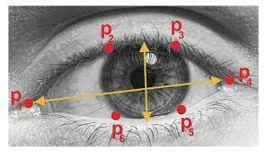
Now using aspect ratio, we calculate the frame check value through which we decide whether either driver is sleeping or not. We decide based on frame check with its value of 30 as a minimum if it's greater than the minimum distance it'll trigger an alarm as we as start to send messages such as text messages, WhatsApp messages, and also email.

Detailed Design

The system has been designed such that the face and eyes of the driver are always monitored and if the predefined levels of alertness are observed to be defaulted and compromised, then an appropriate alarm is set with messages and email, and accordingly, action is taken to prevent any fatalities. The camera is set at top of the vehicle opposite the face of the driver, to continuously monitor the driver. Upon the detection of drowsiness or sleep, the system in the vehicle generates an alert with additional procedures to warn the driver.

7. EXPERIMENTAL RESULTS

Result 1: The face Is Properly aligned and we can see green marks around the eyes.
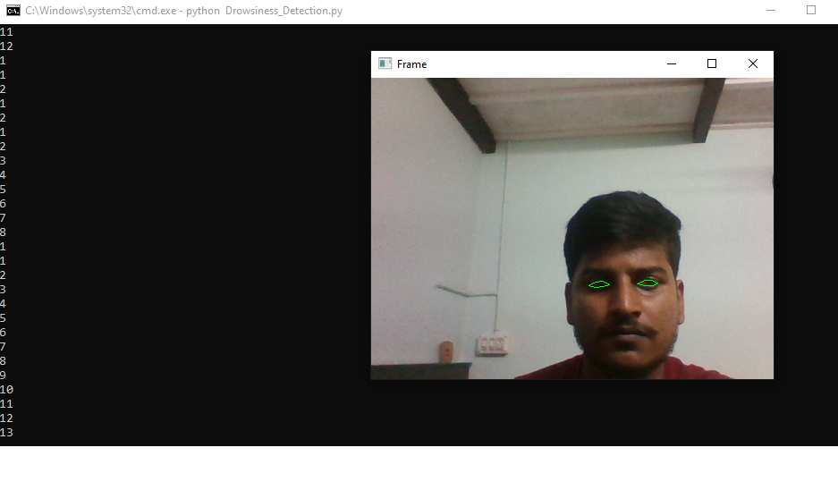

Result 2: In this one, we can see the driver feeling bit sleepy
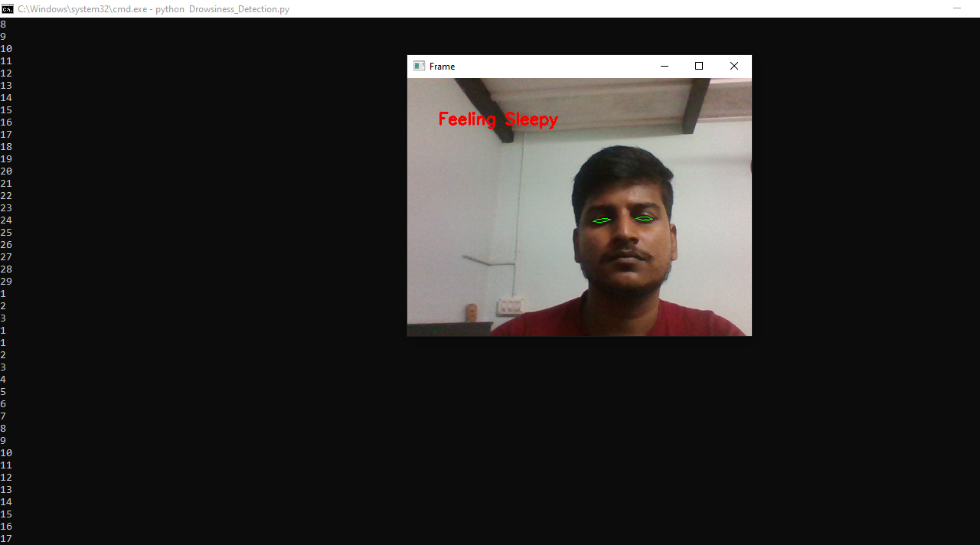

Result 3: Showing the driver is a completely asleep and alert message.

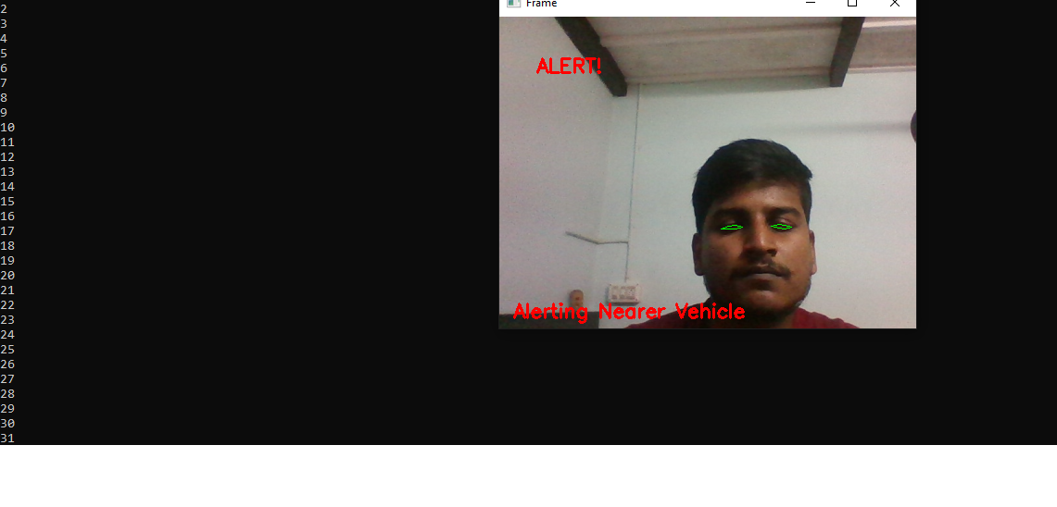

Result: Messages that are triggered due to sleepiness of the driver

Text Message

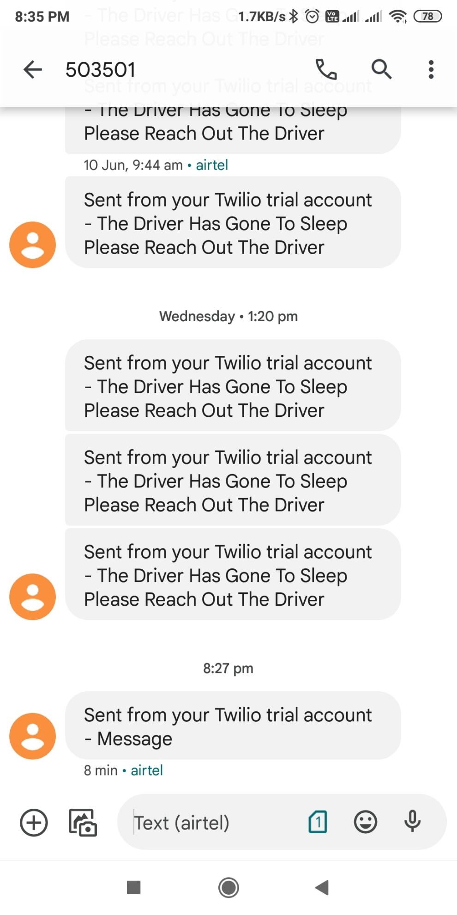

WhatsApp Message



Email Message



Performance Analysis
I/P | DROWSINESS DETECTION
Result 1 | Not detected
Result 2 | Feeling Sleepy Stage
Result 3 | Completely in Sleep

8. CONCLUSION AND FUTURE SCOPE

The developed model is capable of detecting drowsiness by monitoring the eyes.68landmarks are used to detect import features on the face. The inputs given to these methods are facial landmarks which are obtained from facial landmark detection. This module deals with the EAR function which computes the ratio of distances between horizontal and vertical eye landmarks. An alert module is also deployed with messaging features as well. The whole project is designed to decrease the accidents and contribute to the technology to prevent fatalities caused due to road accidents. The future work of this paper can be focused on the use of outer factors for measuring fatigue and drowsiness. The outer factors may be weather conditions state of the vehicle, time of sleeping, and, mechanical data. One of the important steps of preventive measures that are needed to solve the problem is by continuously observing the driver's state and giving information about their state to the driver so that they can take necessary action. In the future, more work can be done to automate the zoom on the eyes after they are localized.

LIMITATIONS

The accuracy of the model degrades if the frames are not captured clearly due to any kind of obstacles such as goggles or sunglass. Camera operations such as auto adjustment concerning zoom and rotation are not considered in conducting experiments. Once the eyes are localized, zooming in automatically will help increase accuracy. It is not possible to detect the eyes if they are not facing the camera.

References

[1] "EEG-BASED DROWSINESS DETECTION FOR SAFE DRIVING USING CHAOTIC FEATURES AND STATISTICAL TESTS," Z. MARDI, S. N. ASHTIANI, AND M. MIKAILI, JOURNAL OF MEDICAL SIGNALS AND SENSORS, VOL. 1, PP. 130–137, 2011.
[2] "SQUEEZENET: ALEXNET-LEVEL ACCURACY WITH 50X FEWER PARAMETERS AND 0.5MB MODEL SIZE," F. N. IANDOLA, S. HAN, M. W. MOSKEWICZ, K. ASHRAF, W. J. DALLY, AND K. KEUTZER, PROCEEDINGS OF THE INTERNATIONAL CONFERENCE OF LEARNING REPRESENTATIONS, PP. 1-13, 2017.
[3] BOOK- COMPUTATIONALLY EFFICIENT FACE DETECTION; B. SCHLKOPF-A. BLAKE, S. ROMDHANI, AND P. TORR.
[4] BOOK- JAIN, “FACE DETECTION IN COLOR IMAGES; R. L. HSU, M. ABDEL-MOTTALEB, AND A. K. JAIN.
[5] BOOK- OPEN/CLOSED EYE ANALYSIS FOR DROWSINESS DETECTION; P.R. TABRIZI AND R. A. ZOROOFI
[6] PAPER -DRIVER DROWSINESS DETECTION SYSTEMS AND SOLUTIONS; ALEKSANDAR ČOLIĆ, OGE MARQUES, BORKO FURHT
[7] PAPER - DRIVER DROWSINESS DETECTION USING ANN IMAGE PROCESSING; T. Vesselenyi, S. Moca, A. Rus, T. Mitra and B. Tătaru 2017

